**Exercise – File to File Scenario (Using Content Conversion):**

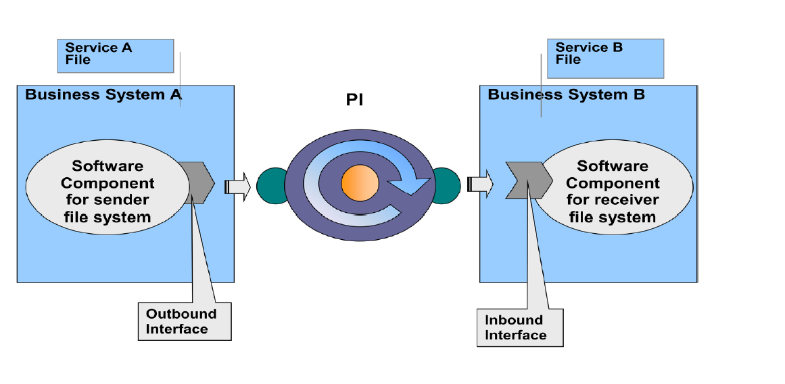

**Pre- requisite to start this development-**

**Integration Repository** - Software Components defined for Sender and Receiver File System in SLD

**Business Logic behind this development**

Sender File system will place comma separated flat file on FTP server. SAP PI picks up the file and does require mapping. The result of mapping needs to be sent to the Receiver (File) system as XML File.

**Design**

1. **Access to the Process Integration Tools**

Link provided

<http://in-mum-solman:50000/dir/start/index.jsp>

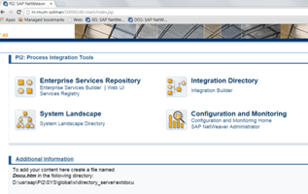

**2. Access Enterprise Service Repository(ESR)**

Click on the link Enterprise Service Builder under Enterprise Service Repository. The following

Screen appears –

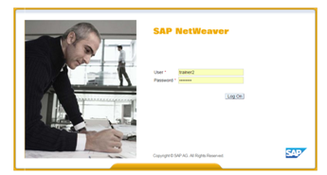

Login to PI using your user id and password.

**3. Import the software component define in SLD**

Import the following software component defined for the scenario into ESR if it is already not done.

NOTE: Please ask your instructor and use any one of the below SWCV as instructed.

* CAPGEMINI_TRAINING_6B of capgemini
* CAPGEMINI_TRAINING_DTP of capgemini
* CAPGEMINI_TRAINING_MUMBAI of capgemini

Click on new under object and select SWCV under Work Areas

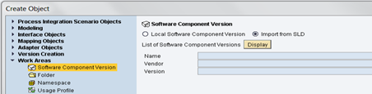

Click on Display and select the required sender and receiver business system to be imported into ESR for further development

**4. Define Namespace**

You Define a Namespace for you SWCV that uniquely identifies all the objects you create in Repository.

Right click software component version and select Namespace from the context.

Create the following namespace

urn:sampleFCC_to_XMLFile_***<<your last thre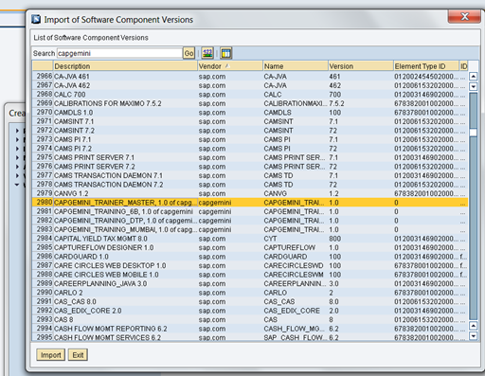e digit of employee ID>>***

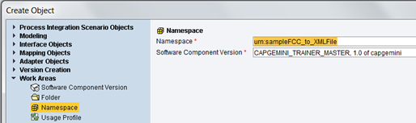

After creating and saving it appears like below in your SWCV –

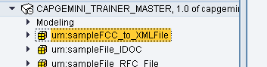

Activate the changes made in the objects by going to the Change Lists tab(left navigation bar).

**5. Define Data Type**

1. Date type(DT_File_Sender_<Name/EmpNo> for Sender System (FileSystemA)

2. Date type(DT_File_Receiver_< Name/EmpNo >) for Receiver System (FileSystemB)

Create data types with required structure and type of elements as below. Right click on the namespace and add new Data type under Interface objects context. he following screen appears. Enter the name of the Data type.

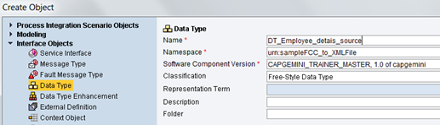

Create DT_File_Sender_< Name/EmpNo > for the outbound message from the sender FileA System. Define the structure of your data type with nodes and fields and as depicted below and save upon completion if the data type.

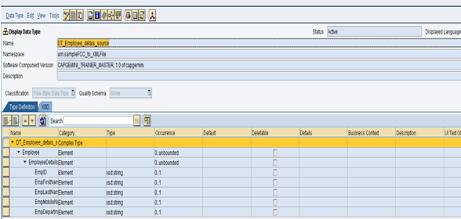

Similarly create DT_File_Receiver_< Name/EmpNo > for the inbound message to the receiver FileB System. Save after completion of the data type.

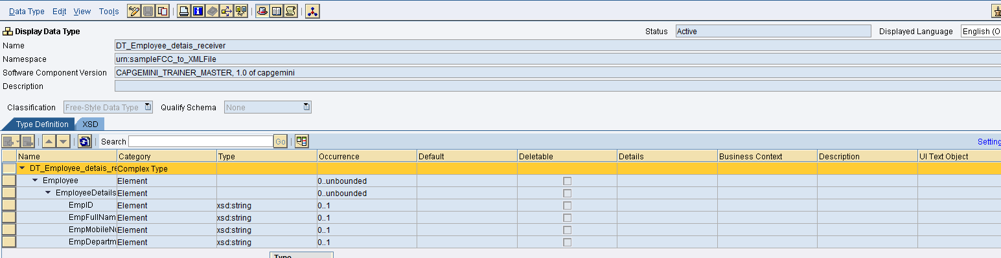

**6. Define Message Type**

1. Message type(MT_File_Sender_<Name/EmpNo> for Sender System (FileSystemA).

2. Message type(MT_File_ Receiver_< Name/EmpNo >) for Receiver System (FileSystemB)

Create MT_File_Sender_<Name/EmpNo> for the message coming from sender FileSytemA and MT_File_ Receiver_< Name/EmpNo > for the message to be sent to receiver FileSystemB based on the following steps

Right click on the namespace and add new Message type under Interface objects context.

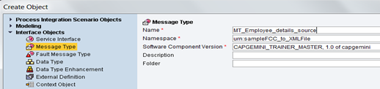

Select the Data type (created in the previous step)for the message type. The Namespace automatically gets populated. This is the message type for sender system. Save after completing.

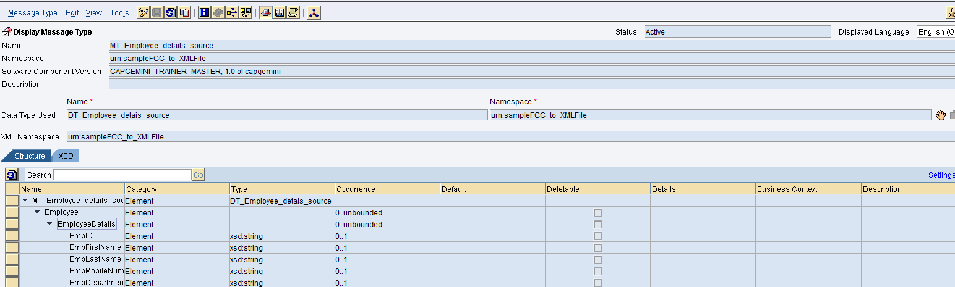

Similarly create MT_File_Receiver_< Name/EmpNo > for the receiver FileB System as below

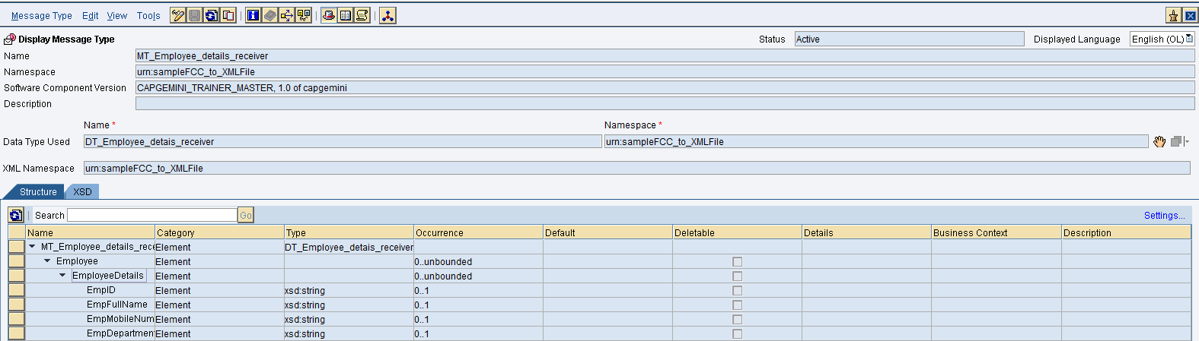

**7. Create Service Interfaces**

1. Service Interface(SI_File_Sender_Out_< Name/EmpNo> ) for Sender System (FileSystemA).

2. Service Interface(SI_File_Receiver_In_< Name/EmpNo> ) for Receiver System (FileSystemB).

Service Interfaces specify the Mode(Sync/Async), direction(inbound/outbound) and the corresponding Message Type. Define two Service Interfaces using the attributes given below. Save after creating both service interfaces.

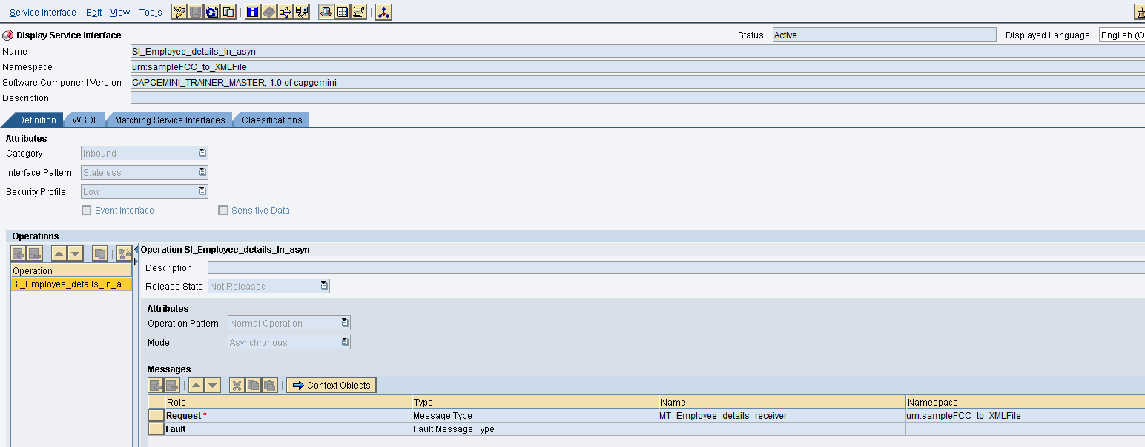

This is the service interface for the receiver system. Save after completing

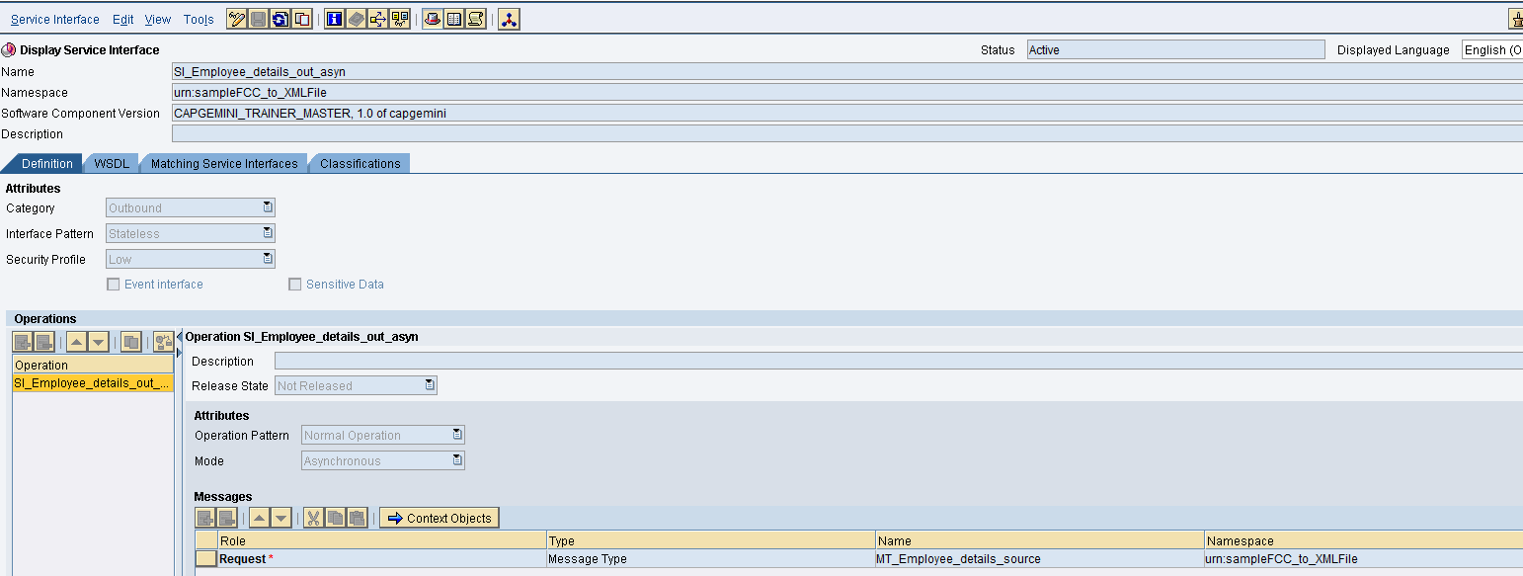

This is the service interface for the sender system. Save after completing

**8. Create the Message Mapping**

1. MM_FileA_FileB_<Name/EmpNo> in the receiver File SystemB

The mapping in this scenario is one-to-one. The names of the source field and target fields are identical. To perform a mapping, drag the source fields and drop on the target field. The mapping would be displayed in the graphical display.

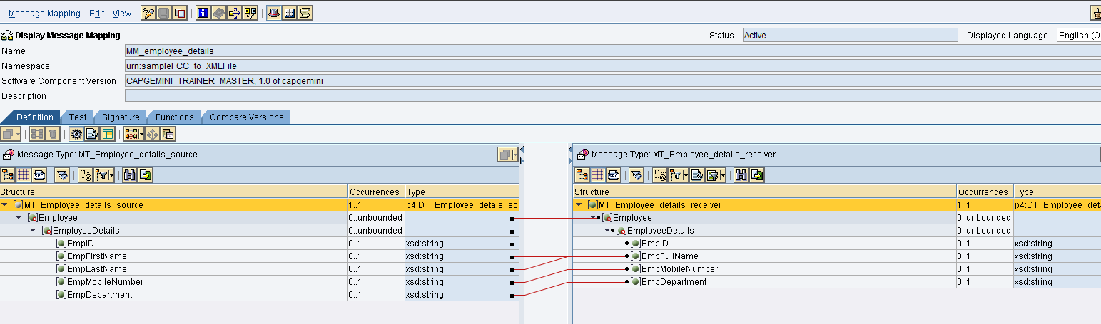

For the field EmpFullName use the concat function present in the Text option located below the screen. The mapping for the field is shown below

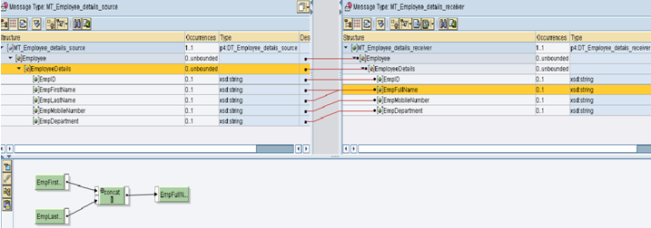

You can test you mapping by going to test Tab. You can select either of the two buttons from the toolbar to test your scenario.

1. Load XM Instance – load an XML file that contains your test data.

2. Generate Instance – By specifying the value manually.

Now you can test the scenario by clicking the Execute Mapping. The following Screen appears

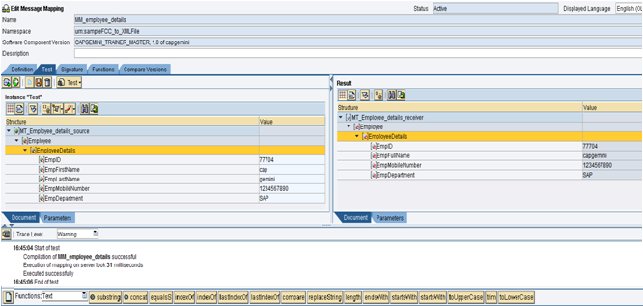

**9. Create the Operation Mapping**

1. OM_FileA_FileB_<Name/EmpNo> in the receiver File SystemB.

In the operation mapping,

Select the source interface as “SI_File_Sender_Out_< Name/EmpNo>” and target interface as

“SI_File_Receiver_In_< Name/EmpNo>”.

Click on the Read Interfaces tab and source/target message types automatically get populated.

Select the message mapping as “MM_FileA_FileB_<Name/EmpNo>

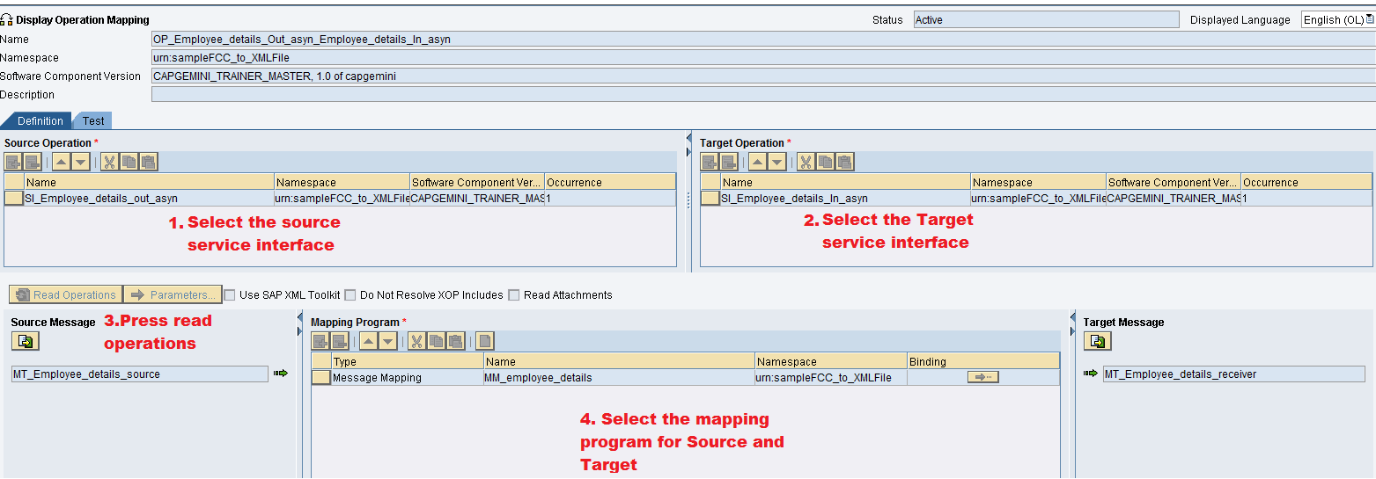

Activate the changes made in the objects by going to the change list tab. You can see the change list under your SWCV. Right click on the standard change list and select Activate from the context.

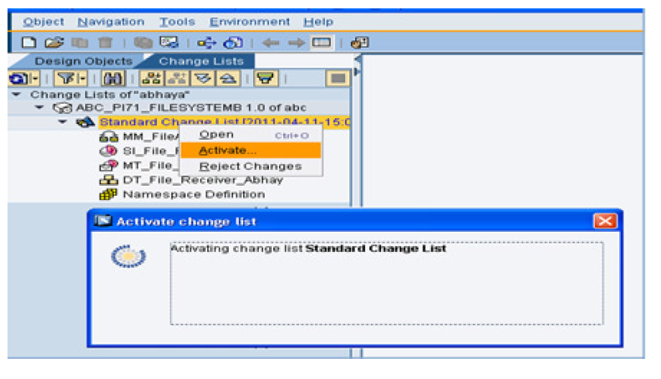

**Configuration**

1. **Access to the Process Integration Tools**

Link provided.

<http://in-mum-solman:50000/dir/start/index.jsp>

1. **Access Integration Directory**

Click on the link Integration Builder under Integration Directory. The following screen appears –

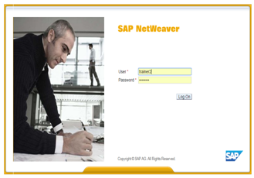

Login to PI using your user id and password.

**3. Create a new Scenario**

Scenario is a place holder for the configuration of interfaces. A scenario can hold the

configuration for multiple interfaces.

Create a Configuration Scenario CS_sampleFile(FCC)2_File**<<last three digit of your employeeID>>** as shown below

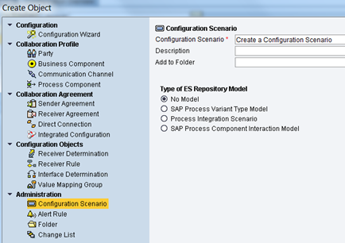

**4. Create Business Component for Sending and receiving File system**

Assign the Service Interfaces to Business Component as shown below

**FOR SENDER COMPONENT**

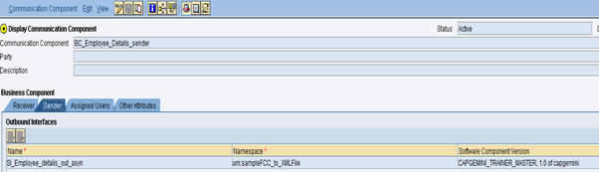

**FOR RECEIVER COMPONENT**

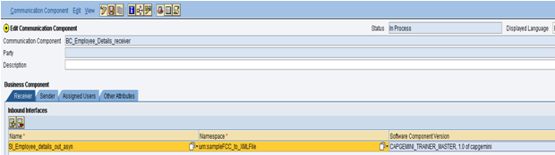

**6. Create Communication Channels**

This communication channel will enable the business component/business system and

integration server to communicate to each other.

**Sender Communication Channel –**

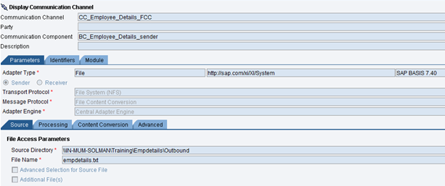

Under Content Conversion enter the details as follows

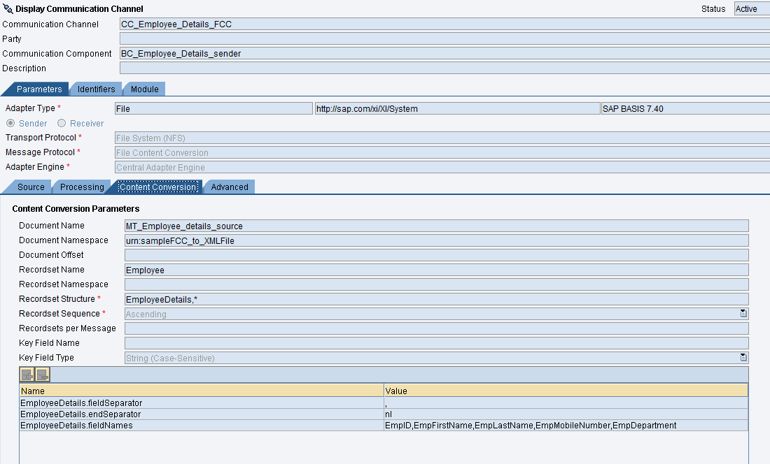

**RECEIVER COMMUNICATION CHANNEL-**

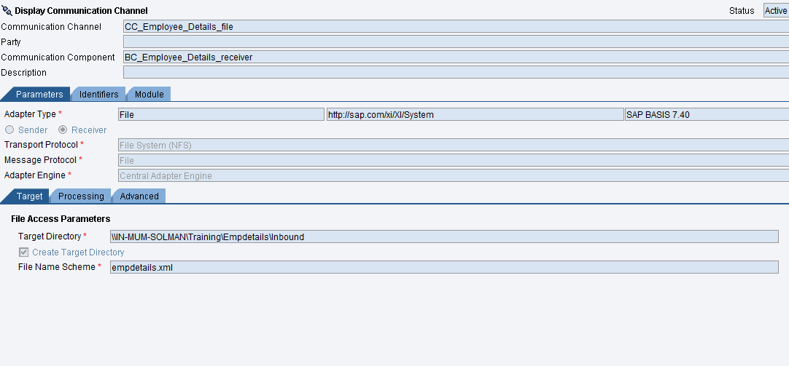

**Note:** Target Directory will depend on the system to which we are connecting. File Name Scheme will can also change as per requirement.

**7. Receiver Determination**

A receiver determination defines one or more receivers for a sender and a outbound Service

interface. Create a new receiver determination, by right the scenario and then select Receiver

Determination under Configuration Objects

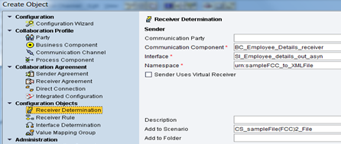

Now add receiver business component –

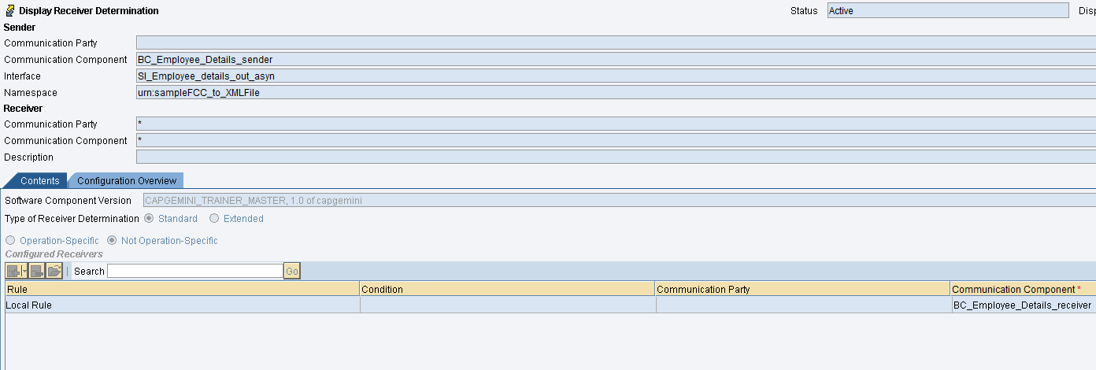

**8. Interface Determination**

In this step, we need to determine the inbound service interface using which the receiver

system is expected to receive data.

Create a new interface determination, by right the scenario and then select Interface

Determination under Configuration Objects , as shown below

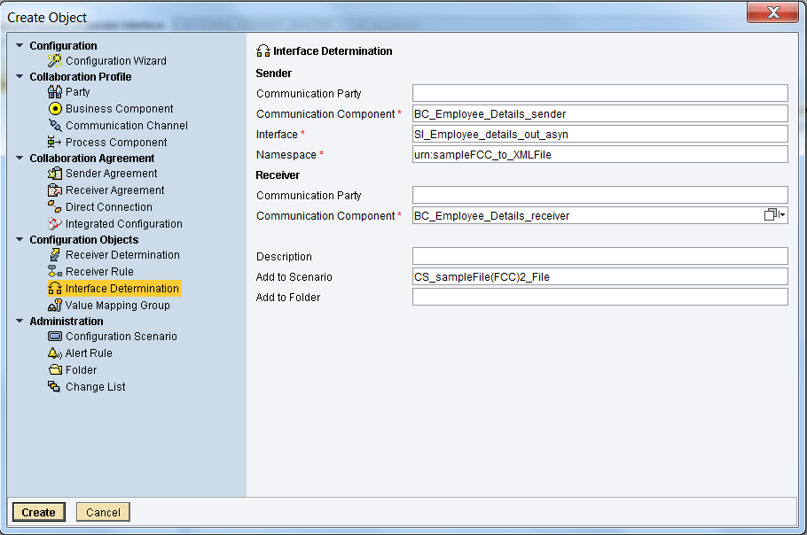

Now add the inbound interface and operation mapping to be used by this scenario

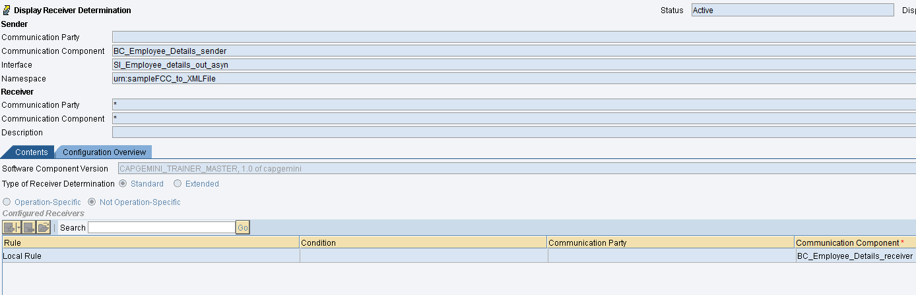

**9. Sender and Receiver Agreement**

The agreements we need to specify the communication channel to be used by sending/receiving systems to actually connect to Integration Engine.

Create the sender and receiver receiver agreement by specifying sender and receiver business

component and adding corresponding communication channel.

**SENDER AGREEMENT**

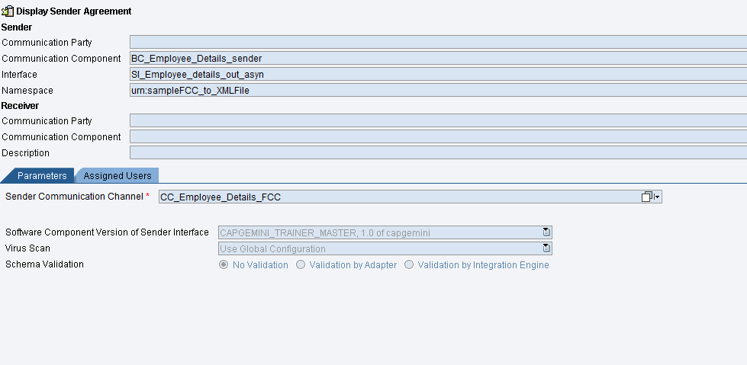

**RECEIVER AGREEMENT**

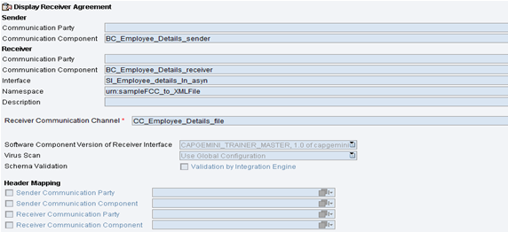

**Testing:**

Create a txt file and place in the source directory mentioned below

\\IN-MUM-SOLMAN\Training\Empdetails\Outbound

Enter the details as given below

**NOTE:** In this scenario we are converting txt file to XML file



Once the file is placed. It is picked up by PI and processed. Then it is placed in the mentioned target directory mentioned below

\\IN-MUM-SOLMAN\Training\Empdetails\Inbound

empdetails.xml will be created

